|  |  |
| --- | --- |
| Fujifilm GF 250mm f/4 R LM OIS WR lens  Ống kính Fujifilm GF 250mm f/4 R LM OIS WR | Chính hãng  FUJIFILM GF 250mm f4 R LM OIS WR  Chính hãng FUJIFILM GF 250mm f4 R LM OIS WR  Chính hãng.6 FUJIFILM GF 250mm f4 R LM OIS WR  Chính hãng.5 FUJIFILM GF 250mm f4 R LM OIS WR  Chính hãng.4 | **Featured information:**  Aperture: F/4-32  Closest focusing distance: 1.4m  Filter size: 82mm  Focal length: 250mm  Price : $ 2800  **Specifications:**  Focal distance  250mm  Largest Aperture  f/4  Smallest Aperture  f/32  Lens Mount  FUJIFILM G  Lens Format  N/A  View  12.5°  Minimum Focus Distance  1.4 m  Magnification  0.22x  Optical Components  16 Elements in 10 Groups  Number of Mouth Blades  9  Focus Type  Autofocus  Anti-Vibration  Yes |

**Overview:**

Magnesium alloy structure helps prevent dust and work in environments with harsh weather conditions. The prefocus set button allows you to save saved focus positions for quick switching between focus distances.

Maximum aperture of f/4 allows effective control over depth of field. The aperture ring intuitively adjusts exposure settings based on the camera. Additionally, the lens is compatible with the optional GF 1.4X TC WR teleconverter, extending the focal length to 350mm for even greater reach.

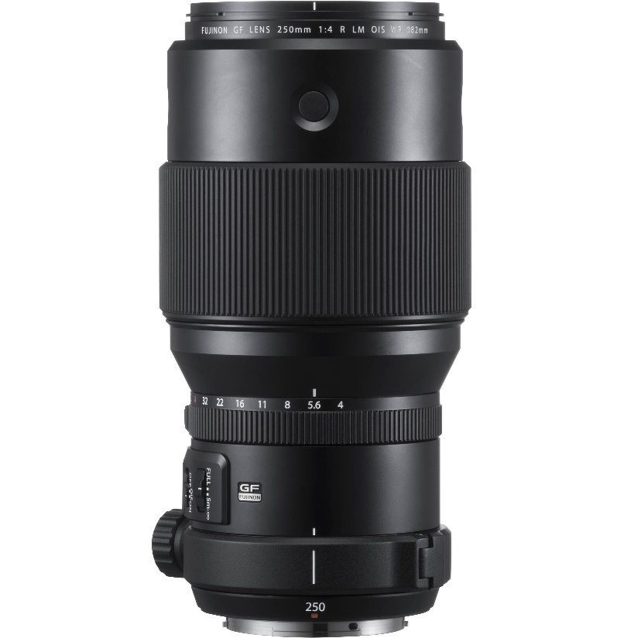

This lens includes 16 elements in 10 groups. Its optical design incorporates one Super ED element and two extra-low chromatic dispersion elements to reduce chromatic aberrations and color fringing across the entire aperture and focus range for clarity and color fidelity remarkable. It allows shooting at a minimum focal length of 1.4m, a maximum magnification ratio of 0.22x and remote macro shooting with large bokeh effects. Additionally, a water-resistant fluorine coating applied to the lens helps block moisture.



Linear AF motor is used for quick, quiet focusing performance. It has an internal focusing mechanism that maintains the overall length of the lens during operation. Consistent optical performance delivers consistent image quality throughout the entire focusing range.



Additionally, a newly updated mechanism that fixes the linear motor position when power is turned off or playback allows the focus position to be fixed. In addition, the optical image stabilization system compensates for camera shake up to 5 stops to help reduce camera shake when shooting handheld, thereby creating sharper images.